1. **Difference between Browser JS(console) vs Nodejs**

**Node JS:**

* Node doesn’t have a predefined “window” object because it doesn’t have a window to draw anything.
* “Location” object is related to a particular url; that means it is page specific. So, node doesn’t require that.
* Of course Node doesn’t have a “document” object also, because it never has to render anything in a page.
* Node has “global”, which is a predefined global object. It contains several functions that are not available in browsers, because they are needed for server side work only.
* “Require” object is predefined in Node which is used to include modules in the app.

**Browser JS (Console):**

* “Window” is a predefined global object which has functions and attributes that have to deal with the window that has been drawn.
* “Location” is another predefined object in browsers, that has all the information about the url we have loaded.
* “Document”, which is also another predefined global variable in browsers, has the html which is rendered.
* Browsers may have an object named “global”, but it will be the exact one as “window”.
* Browsers don’t have “require” predefined. You may include it in your app for asynchronous file loading.
* Modelling is not mandatory in client side JavaScript, i.e. in browsers.

1. **How does the browser render a website?**

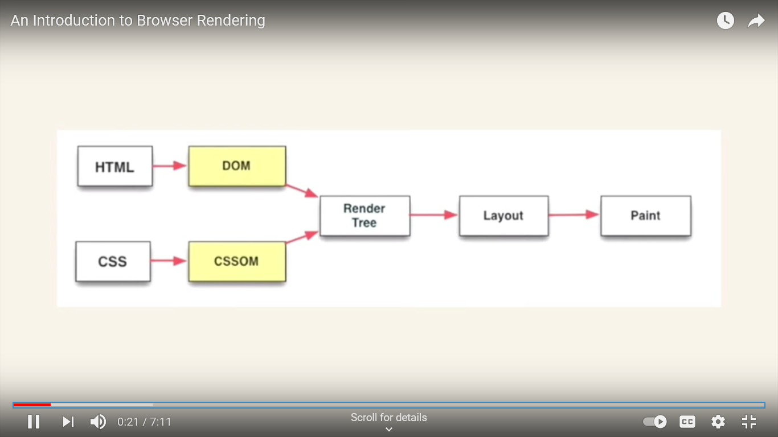

* The browser sends requests to the server and in turn the browser sends responses to the browser.
* Rendering engine plays an important role in it.
* Parsing the HTML document and converting elements to DOM nodes in a tree called the "content tree" - HTML Parser.
* Parsing the style data, both in external CSS files and in style elements together with visual instructions in HTML will be used to create another tree, called “render tree" - CSS Parser.
* After the construction of the render tree it goes through a "layout" process. This means giving each node the exact coordinates where it should appear on the screen
* The next stage is painting-the render tree will be traversed and each node will be painted using the UI backend layer - Painting.
* Thus the information is given to the user. This way the browser renders the information.

**4. typeof():**

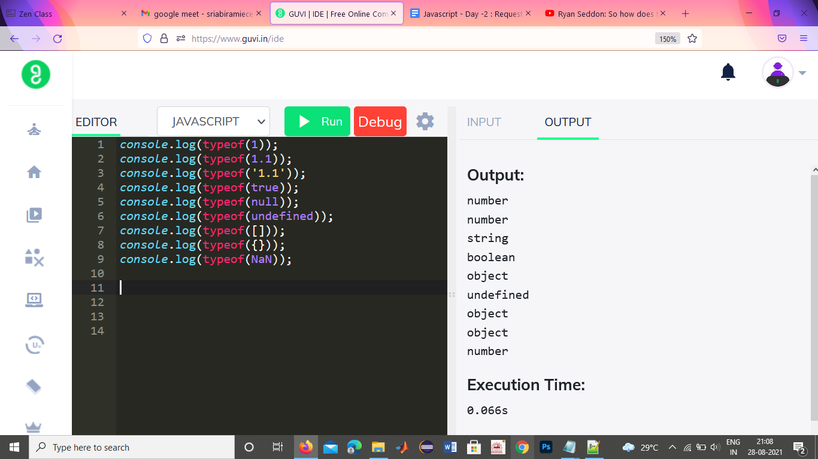

**Explanation:**

Typeof() refers to the data type of value .

Integer, floating, nan are the data type of number.

True, false are the data type of Boolean.

Null, array, brackets, json are the data type of object.

Undefined data type is undefined